Copyright for test papers and marking guides remains with West Australian Test Papers.
Test papers may only be reproduced within the purchasing school according to the advertised Conditions of Sale.
Test papers should be withdrawn after use and stored securely in the school until Friday, 22nd June 2018.



SEMESTER ONE

MATHEMATICS
METHODS
UNITS 1

2018

SOLUTIONS

Calculator−free Solutions

1. (a) (i) 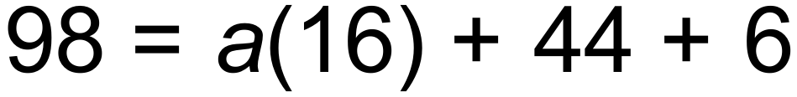
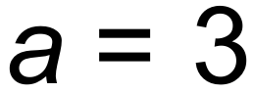
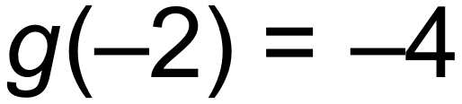
(ii) 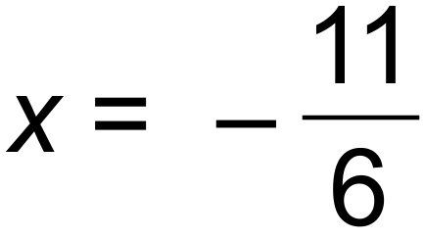
(iii) Minimum
(b) 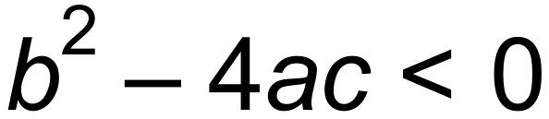
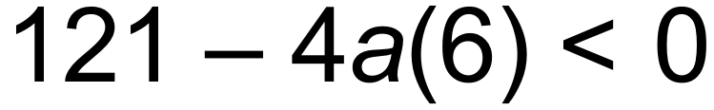
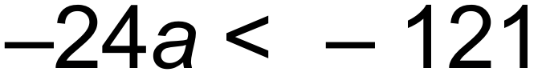
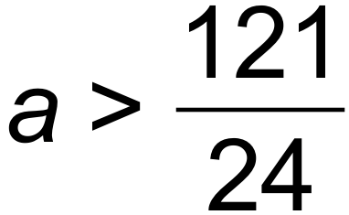 [6]

2. (a) (i) 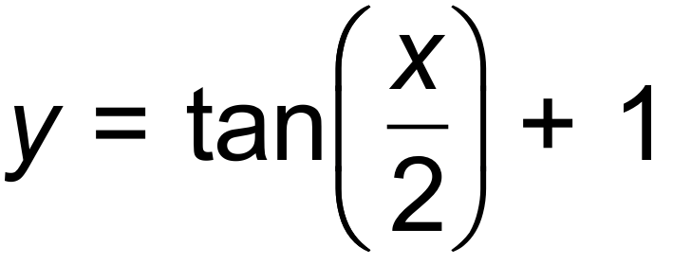
(ii) 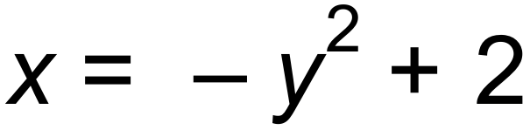
(b)  is a function. For each value of x there is only one corresponding y value. (If a vertical line is drawn anywhere on this function it will only intersect the graph a maximum of once.) [6]

3. (a) Line A: 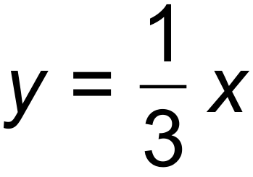
Line B: 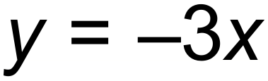
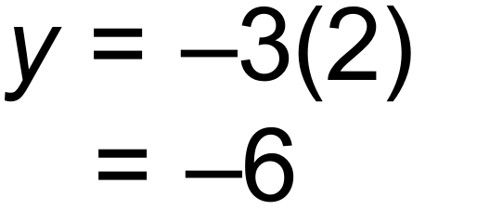
(b) Line CD: 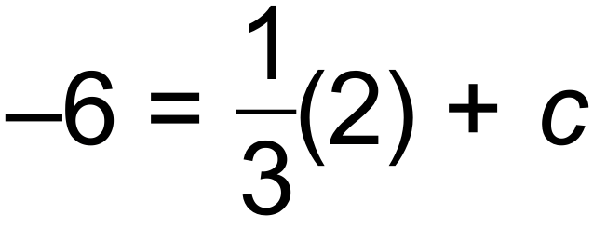
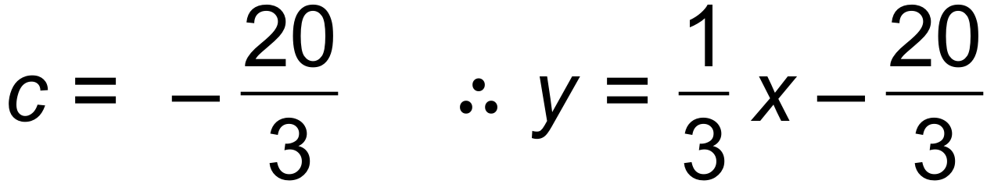
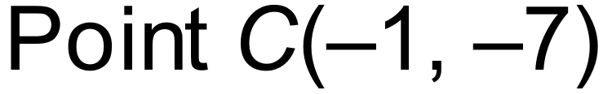
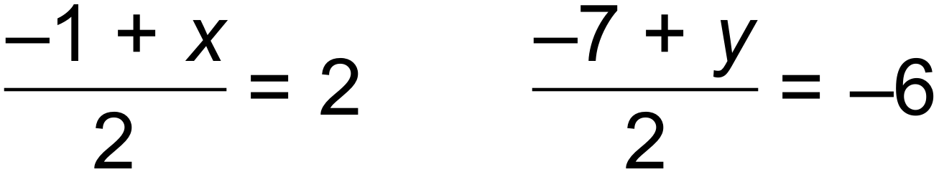
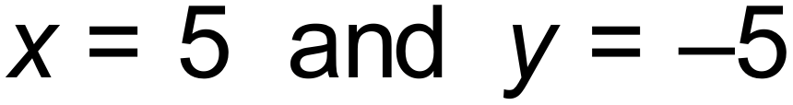
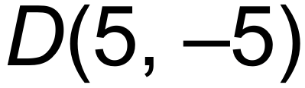 [6]

4. (a) 
(b)
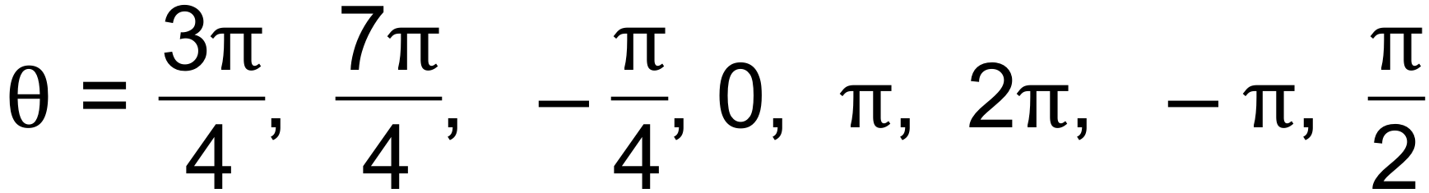 [4]

5. 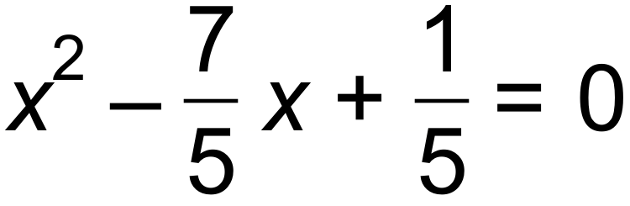
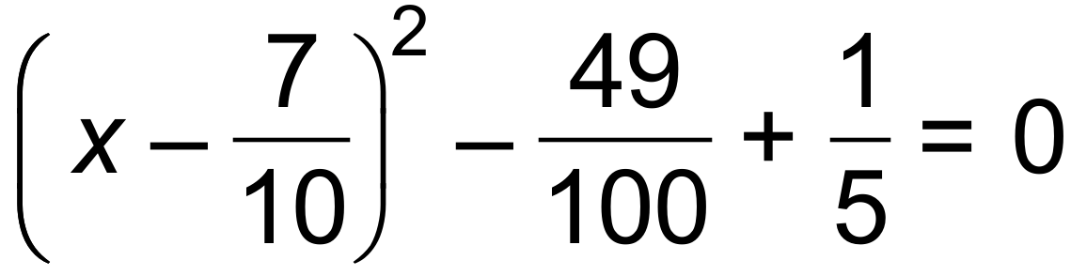
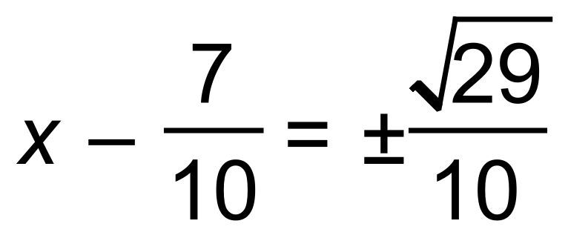
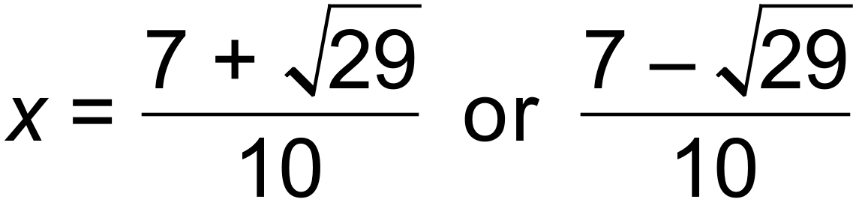 [3]

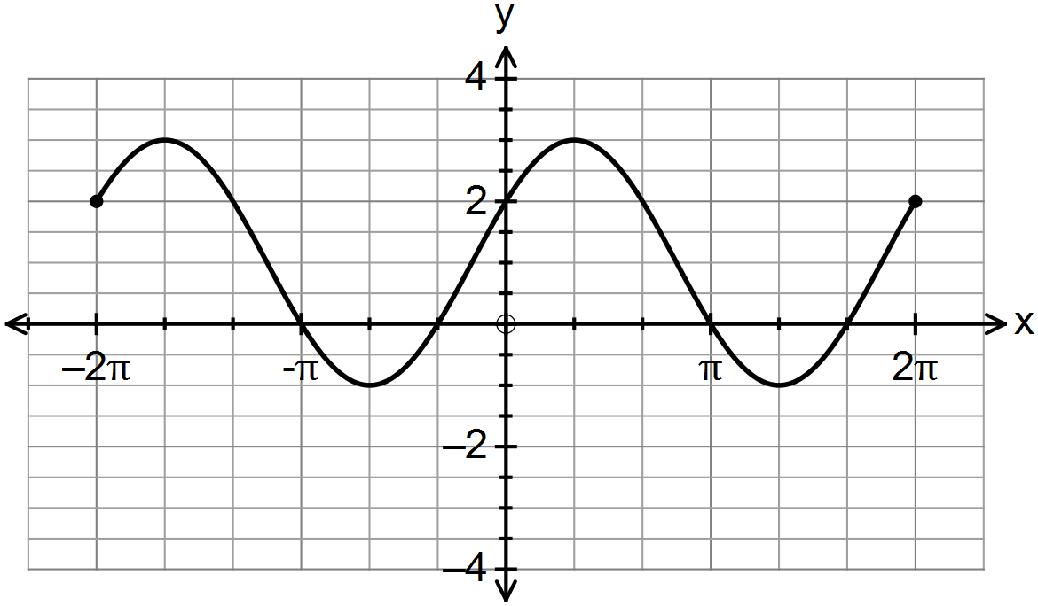6. (a)

(b) (i) 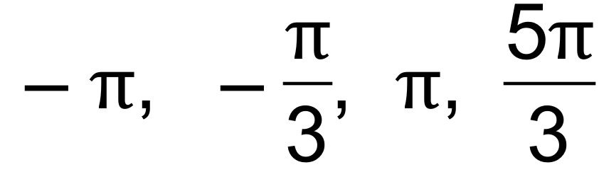
(ii) 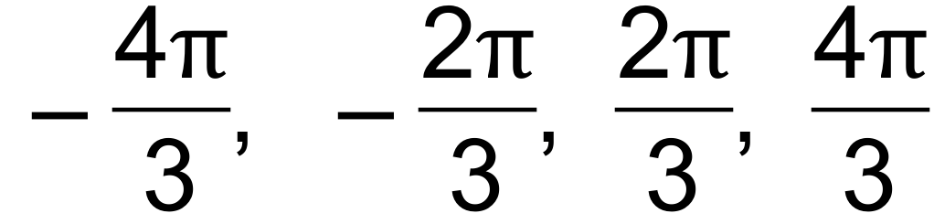 [7]

7. (a) 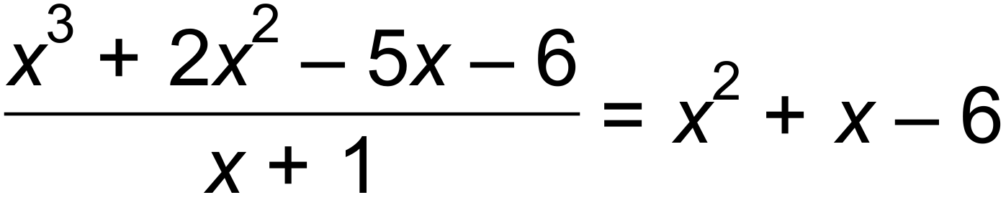
(b) (i) 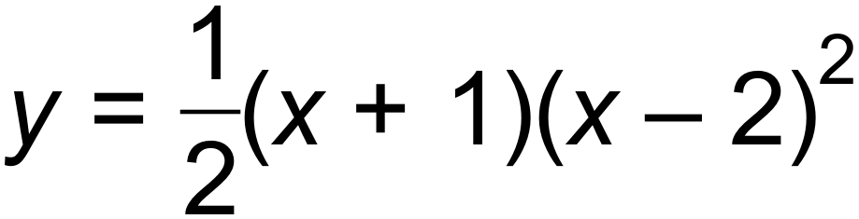
(ii) Vertical dilation, factor .
Horizontal translation one unit to the right
Horizontal dilation, factor .
(ii) 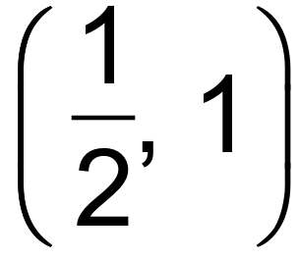
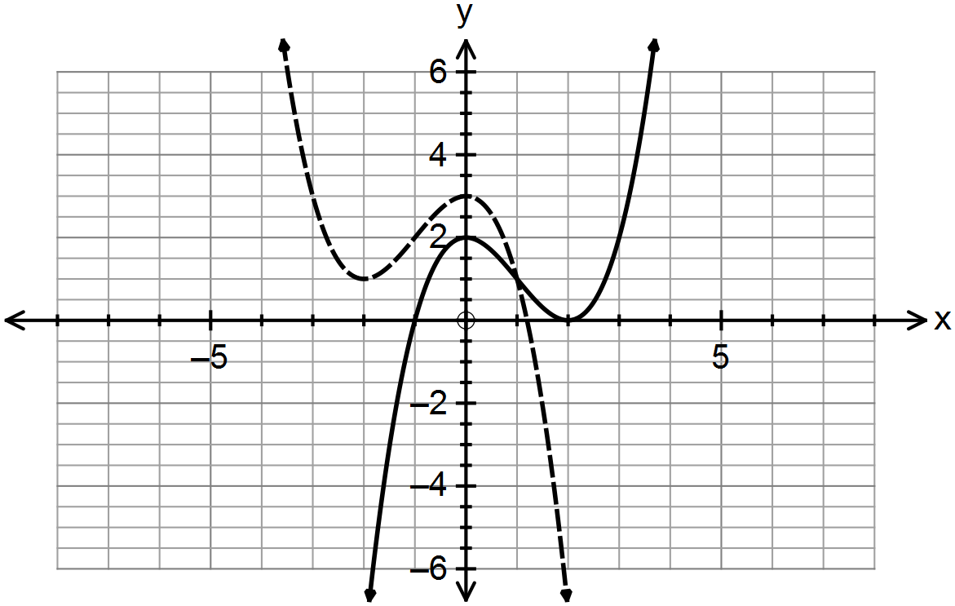 (iii)

[11]

5 | 1 | 5 | 10 | 10 | 5 | 1
6 | 1 | 6 | 15 | 20 | 15 | 6 | 1
8. (a) (i)

(ii)
(b) [6]

9. 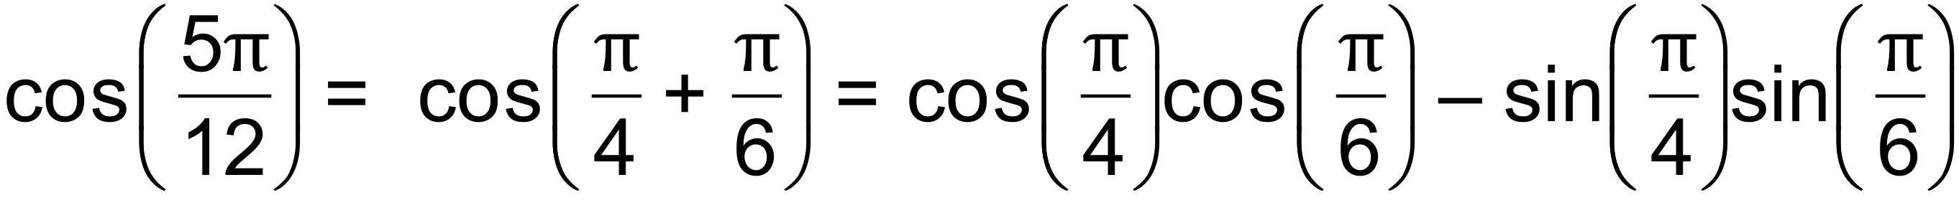
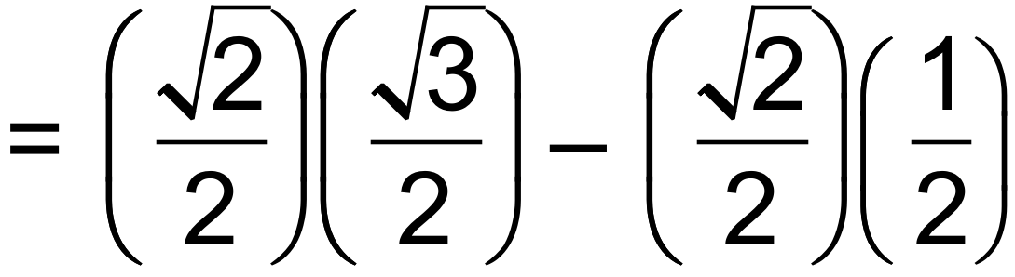
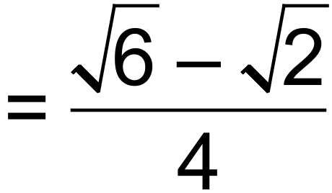 [3]

Calculator−assumed Solutions

10. (a) 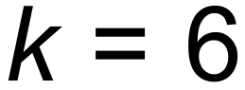
(b) R = 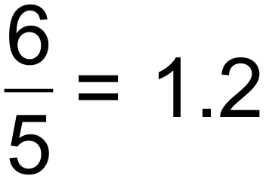 ohms
(c) 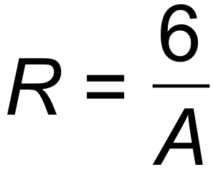
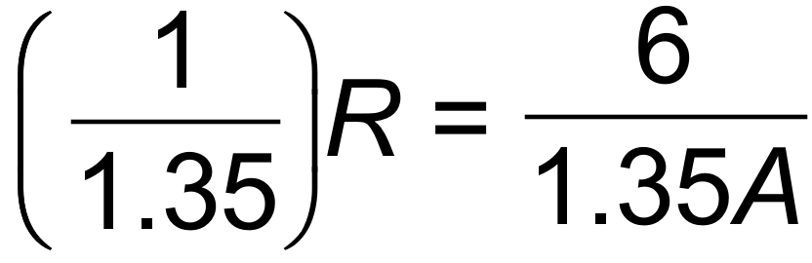
R will decrease by 74%
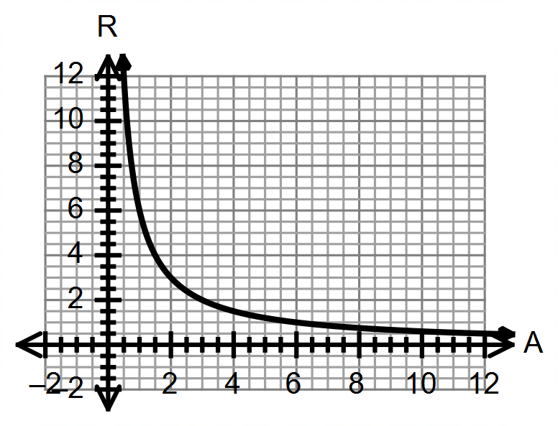(d)

[7]

11. (a)
 |  | Number of toilets
 |  | 1 | 2 | 3 or more | Total
Number of  bedrooms | 1 | 35 | 0 | 0 | 35
 | 2 | 50 | 5 | 0 | 55
 | 3 | 5 | 65 | 15 | 85
 | 4 or more | 0 | 0 | 25 | 25
Total |  | 90 | 70 | 40 | 200

(b) (i) 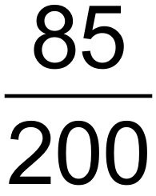
(ii) 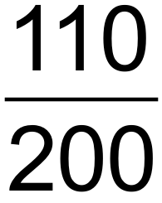

(iii) 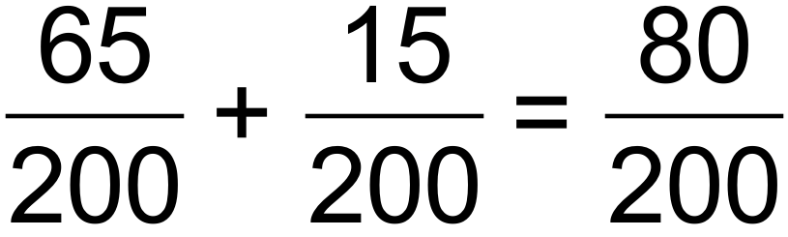
(iv) 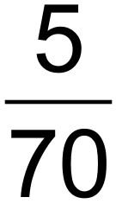
(c) 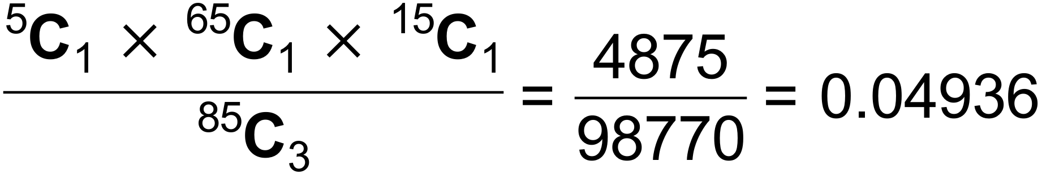 [10]

12. (a) 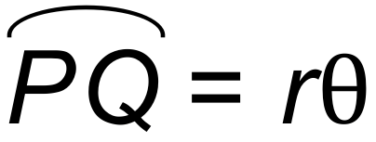

(b) 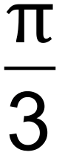
(c) Area of sector = 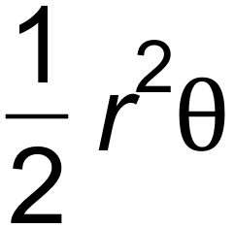
= 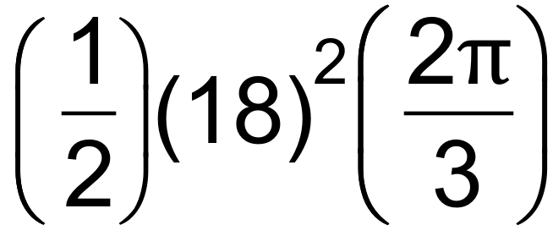
= 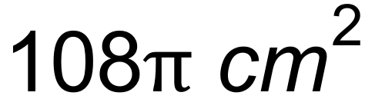
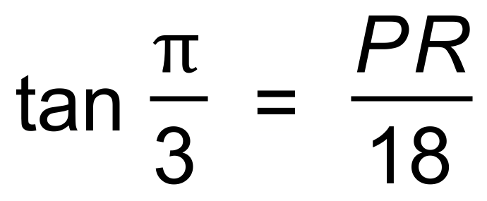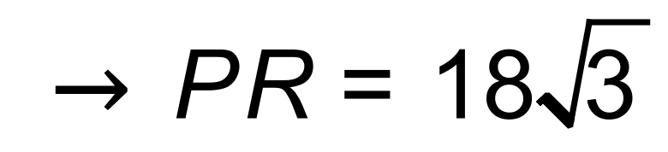
Area of kite = 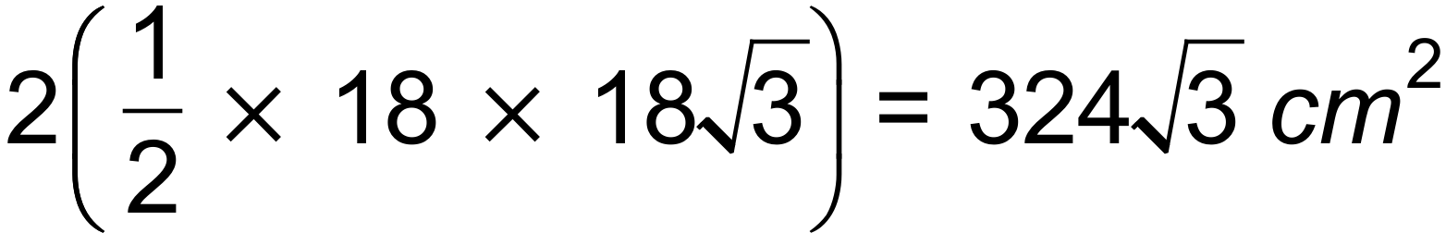
Area of shaded area = 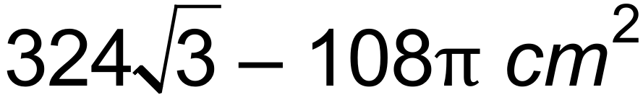 [7]
13. (a) 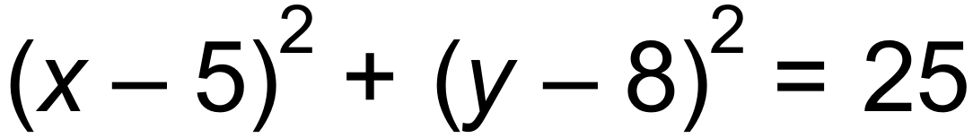
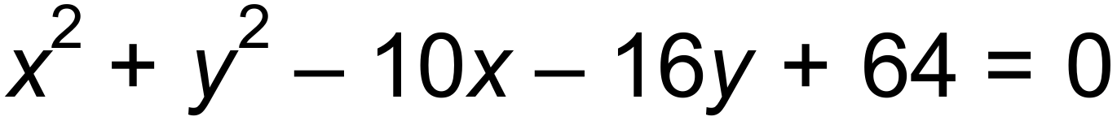
(b) (i) M(2, 4) N(8, 4)
MN = 6 units
(ii) 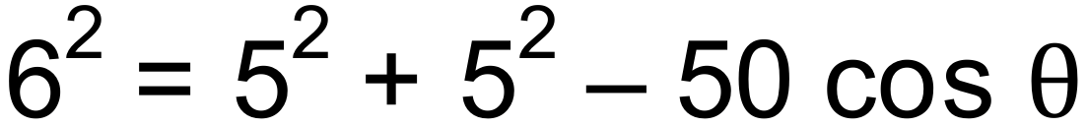
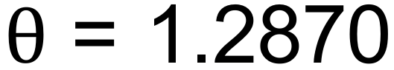
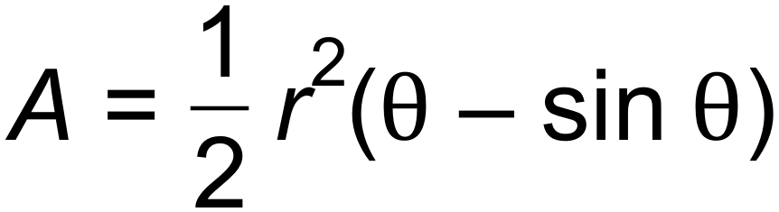
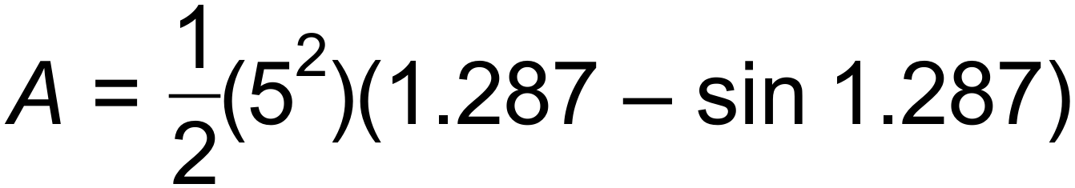
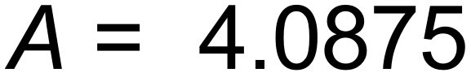 units² [7]

14. (a) (i) 
(ii) 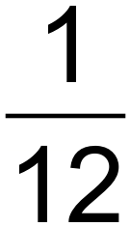
(iii) 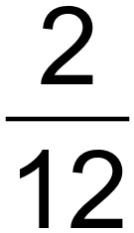
(b) 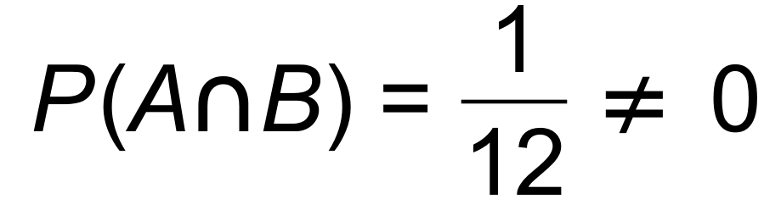
(c) (i) 
(ii) 
(iii) 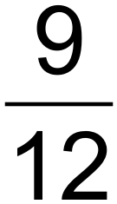 [7]
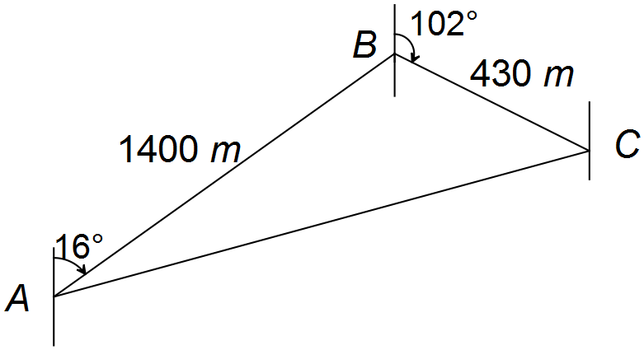
15. (a)



(b) 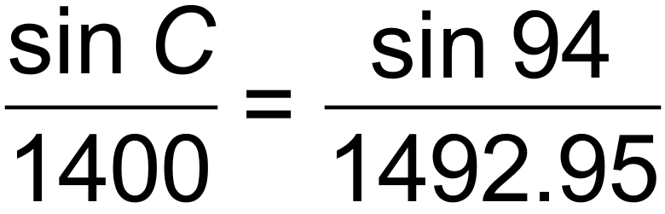

or
Bearing is 212.7°T [6]

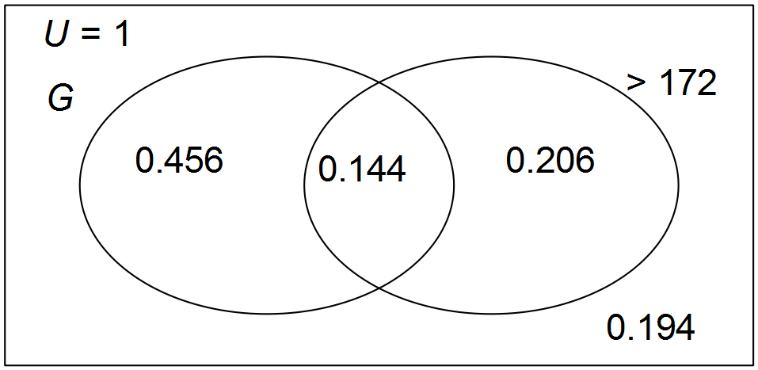16. (a) 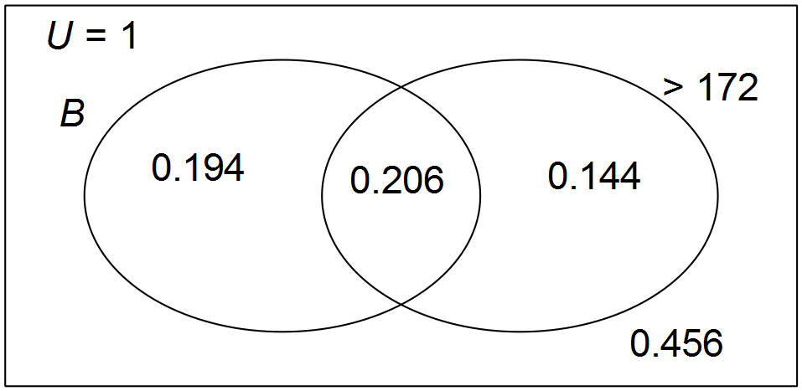

(b) (i) 0.144
(ii) 0.194
(iii) 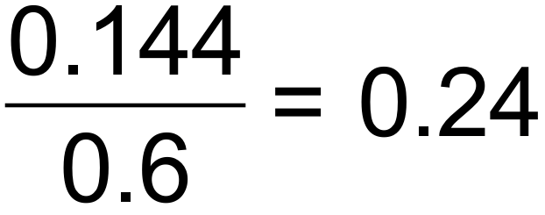
(c) Girls over 172 cm = 38
Boys over 172 cm = 55
38:55 = 1:1.45 [10]

17. (a) 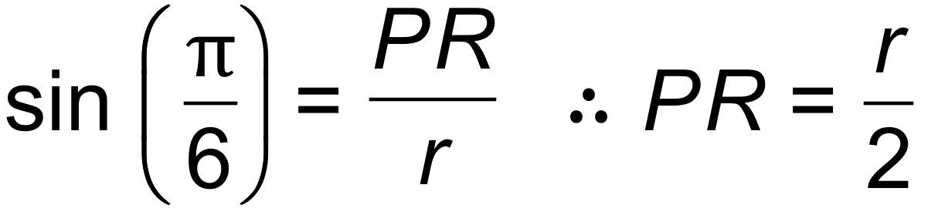
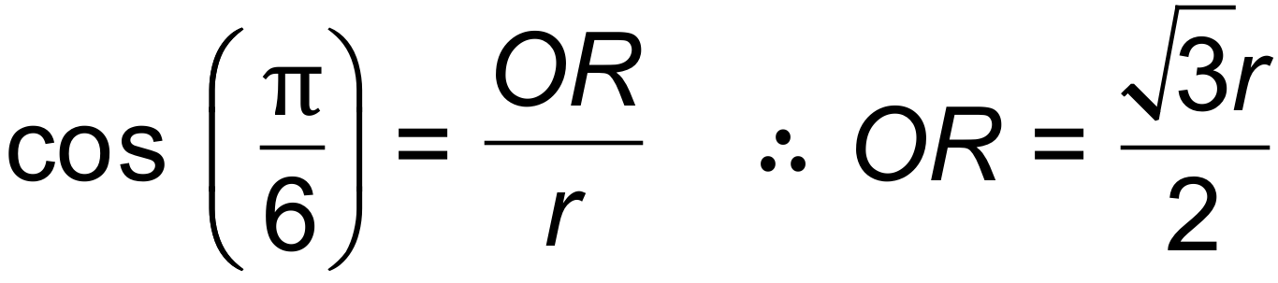
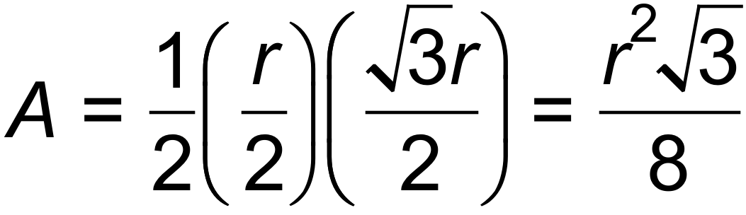
(b) 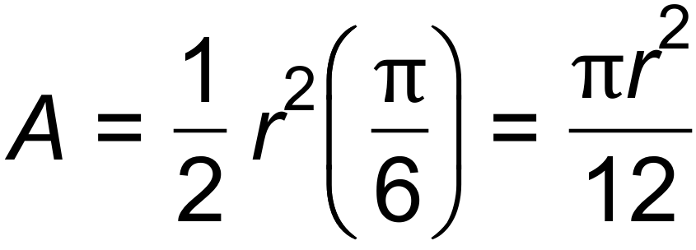
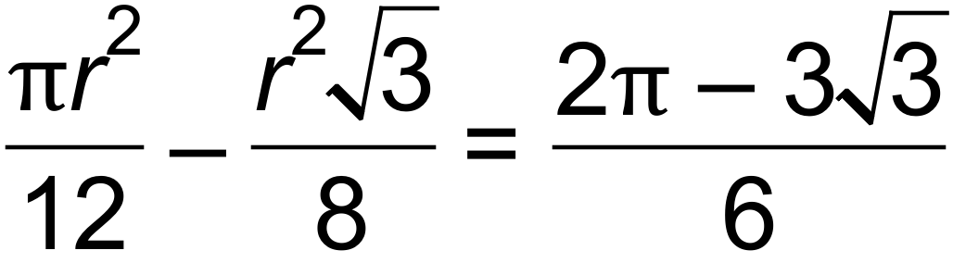
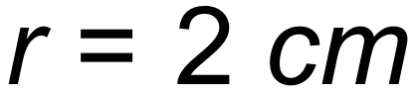 [6]

18. (a) (i) 15! = 1 307 674 368 000

(ii) 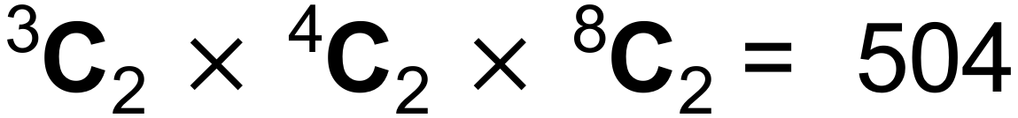
(iii) 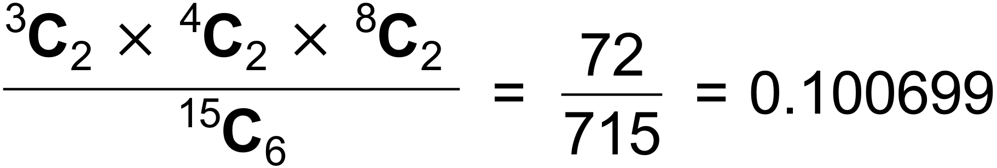
(b) (i)
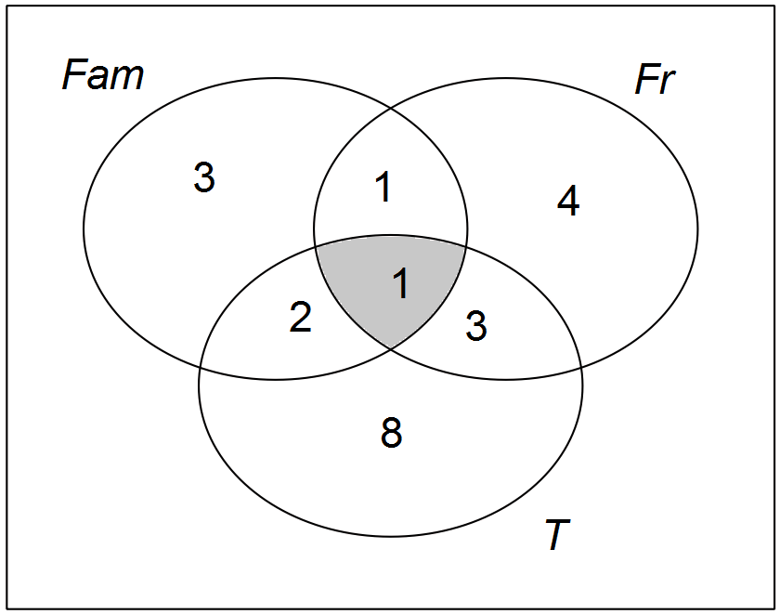

This image has family and friends and travel in it.
(ii) 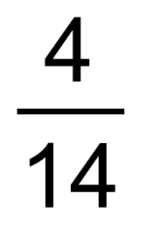 [9]

19. (a) D H
(b) C G
(c) G
(d) G
(e) H
(f) A
(g) E
(h) A B [8]

20. (a)

(b) 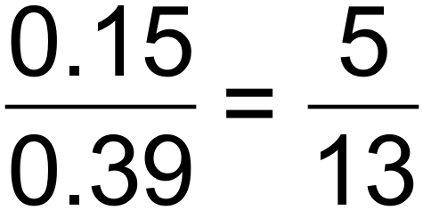
(c) The events are not independent.
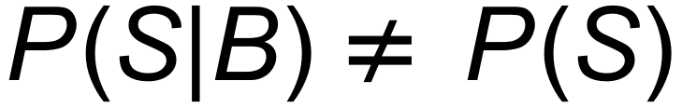
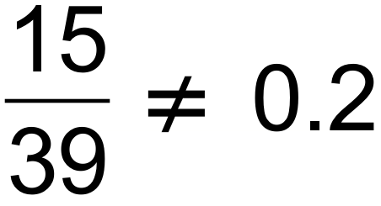 [6]

21. (a) (i) V= 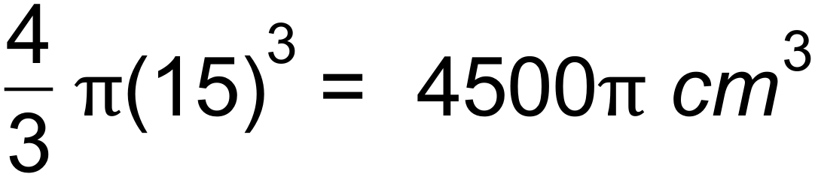
(ii) 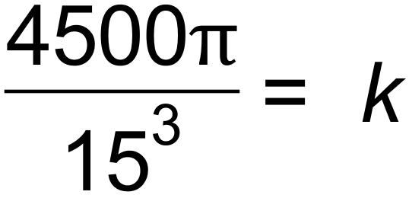
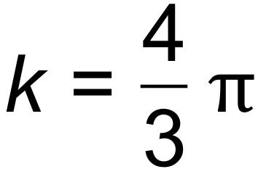
(iii) 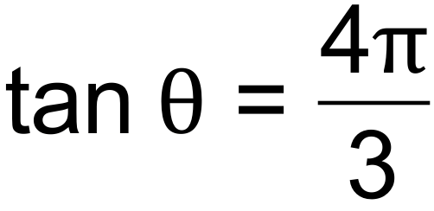
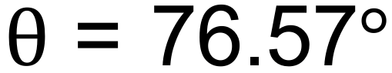
(b) Let x be the length, then 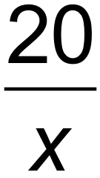 is the width
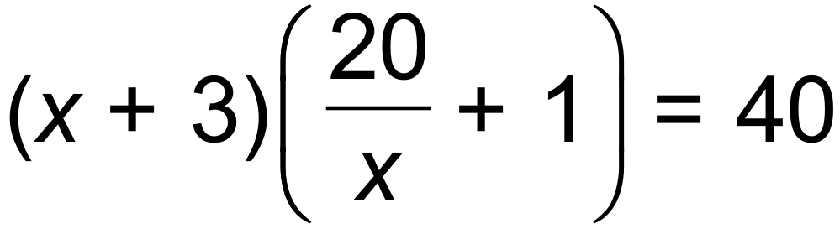
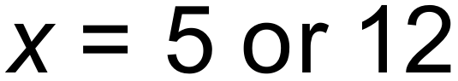
Original dimensions are 4m x 5m or 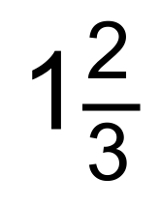m x 12m
(c) Domain: 
Range: 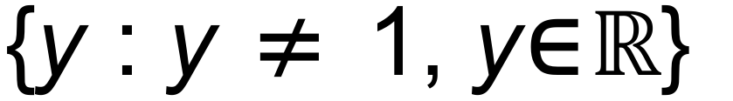 [9]

22. A: 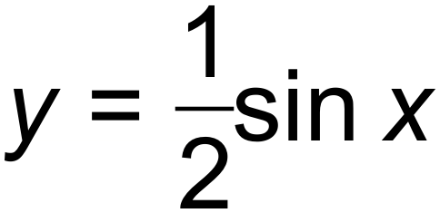 B: 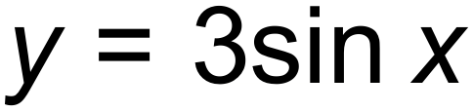
The amplitude for a quieter sound is .
The amplitude increases to 3 to produce a louder sound.
C: 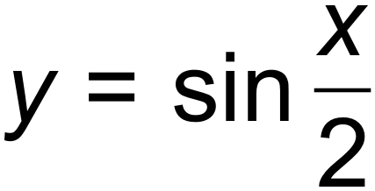 D: 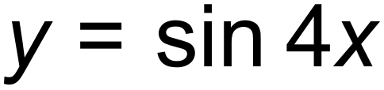
The period for a deeper pitch is 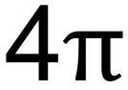
The period for a higher pitch is . [6]

